Title page
Pham Duc Thang,
ID: 001407356,
Course Title: Web Programming 2,
COMP1842

Note: All we need in this logbook is screenshots. All code must be uploaded separately in a ZIP file.

Weekly Tasks

Logbook 4- Week 6 tasks

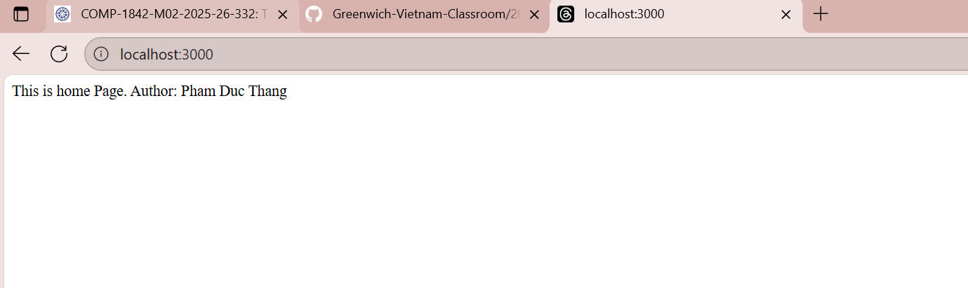
Annotation:
Node.js can act as a web server using its built-in http module. The http.createServer() method creates a server that takes a callback function with two parameters: req (request) and res (response). The req.url property helps identify the current route, and res.write() is used to send content back to the client. This allows Node.js to handle HTTP requests and responses directly without external web server software.

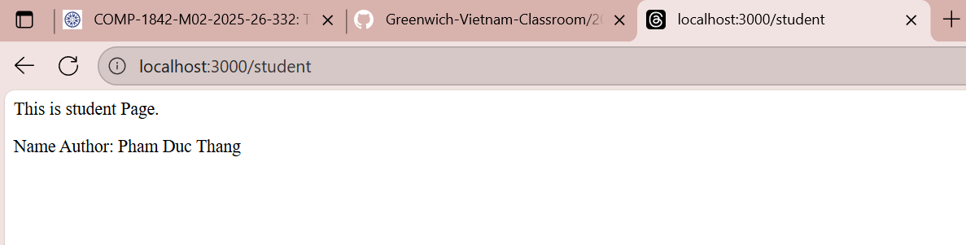

Node.js can handle multiple routes by checking req.url with if–else if–else statements. To send a response, the server first sets the header using res.writeHead(), then writes the body with res.write(), and finally ends the response using res.end(). This defines the full structure of sending data from a Node.js web server.
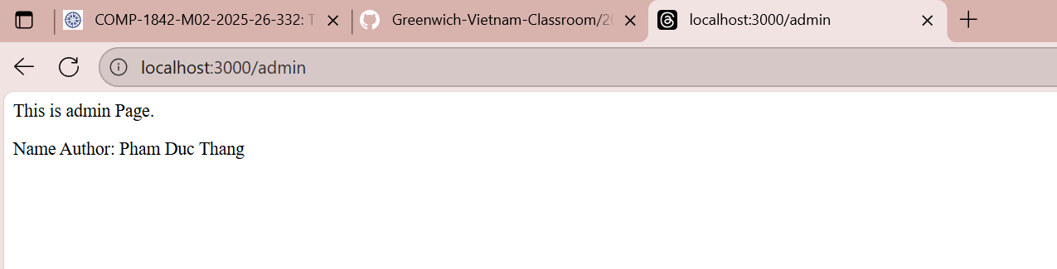

This example is similar to the first two.

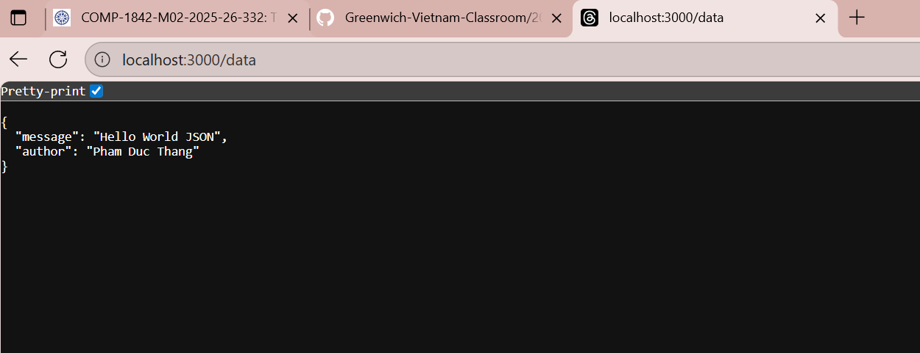

This example is similar to the previous one, but the server sends a JSON response. The method JSON.stringify() is used to convert a JavaScript object into a JSON string before sending it with res.write(), allowing the client to read structured data in JSON format.

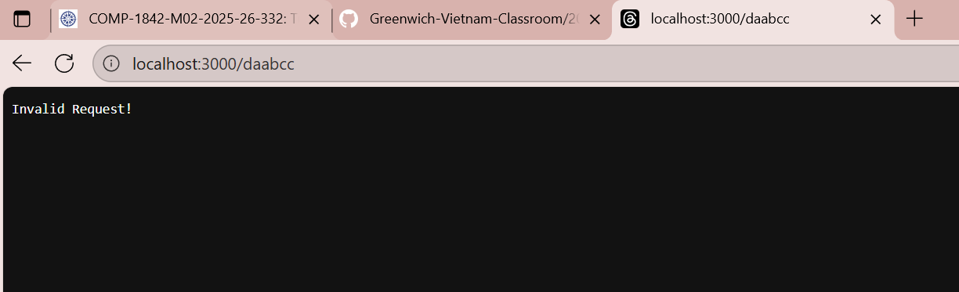
This example demonstrates a default response: if the requested URL does not match any defined route, the server sends a fallback message. This handles undefined routes gracefully.

